Figure-1.2. Complete transistor-level schematic of the CMOS inverter
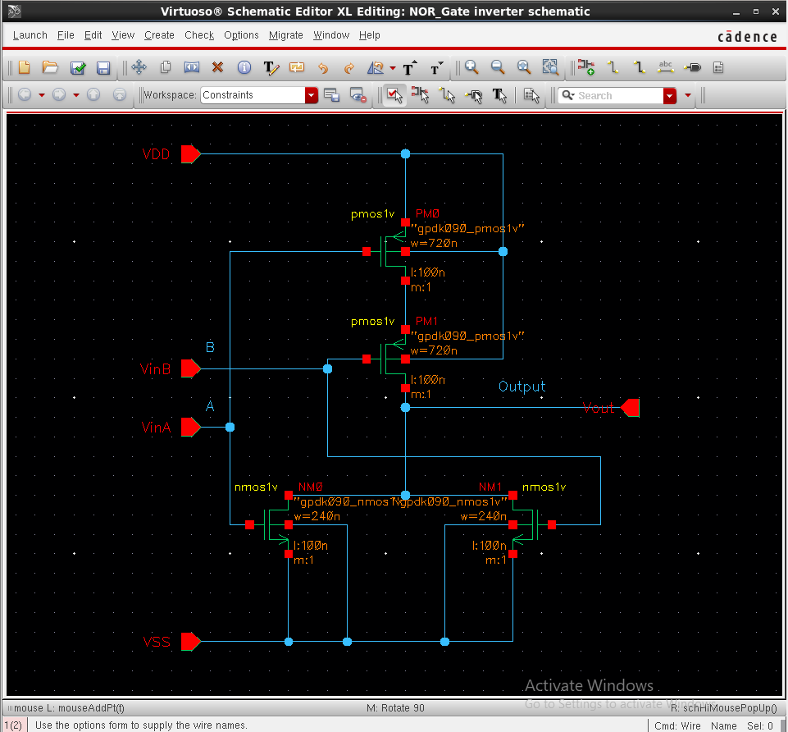

Figure-1.3. Generated schematic symbol of the CMOS NOR inverter
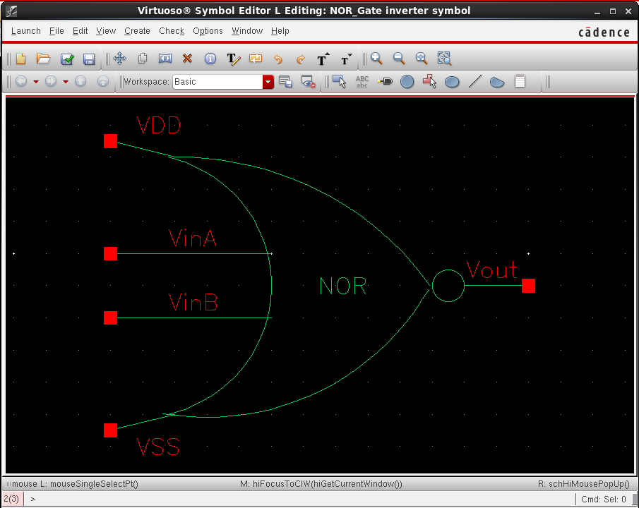

Figure-1.4.4 Test bench schematic (NOR inverter_test)

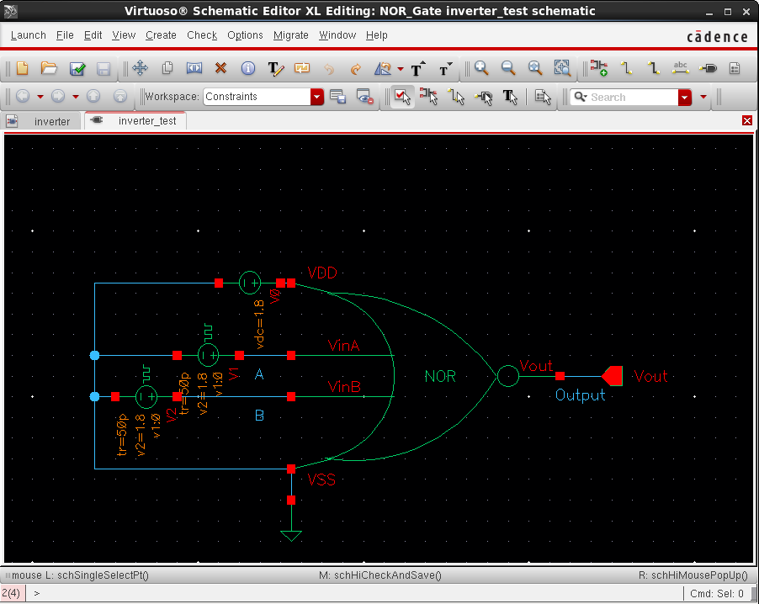

Figure-1.5. NOR Simulation results
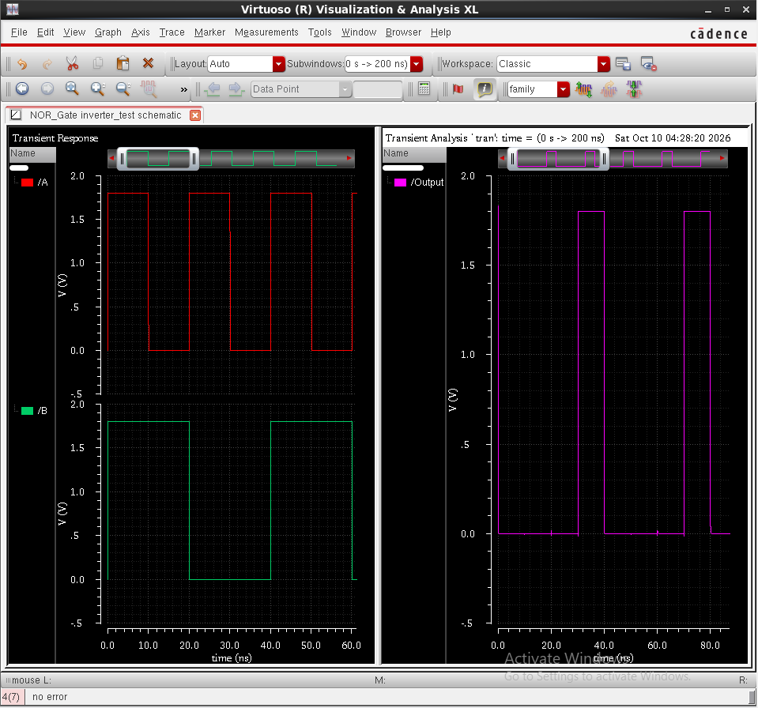

Figure-1.4.1. Add Instance window showing vpulse1 (NOR Input A)
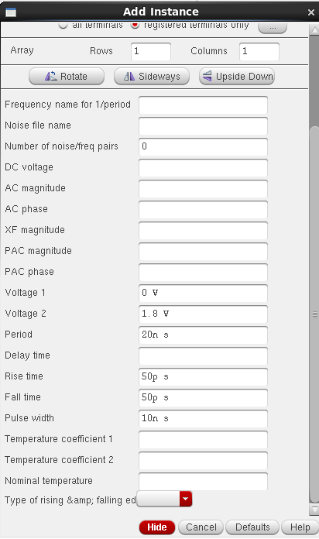

Figure-1.4.2. Add Instance window showing vpulse2 (NOR Input B)
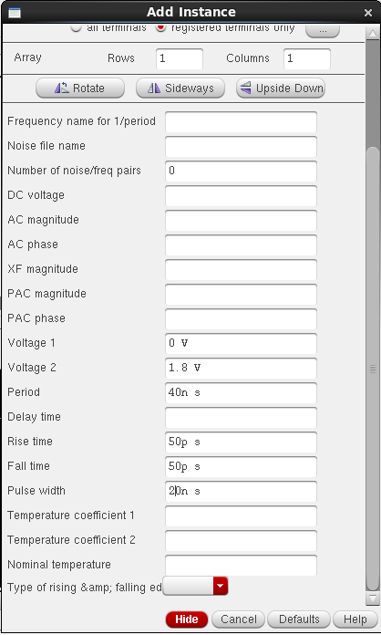

Figure-1.4.3. Add Instance window showing vdc (NOR inverter_test VDD)
